Created by: David Rubio G.
Blog: https://soceame.wordpress.com/
GitHub: https://github.com/DRubioG
Last modification date: 11/03/25

In this post I will explain how to simulate using the ModelSim that comes included with Libero.
To do this, the first thing to do is to have a FW file in the Libero hierarchy.
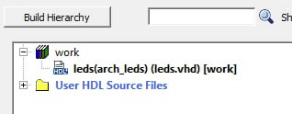
The next thing we do is create a testbench by clicking on Create HDL Testbench.
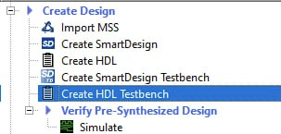
It asks us for the name of the testbench.
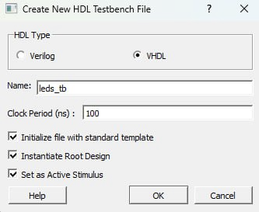
The first thing it does is create a testbench model.
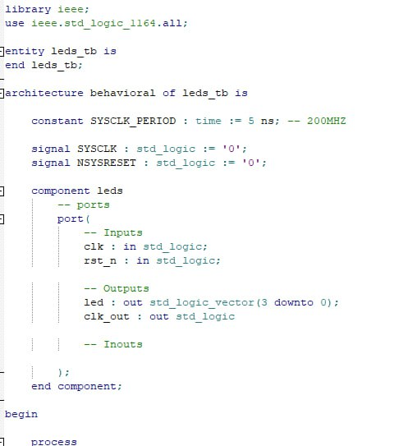
We can change this model to the testbench model we want.
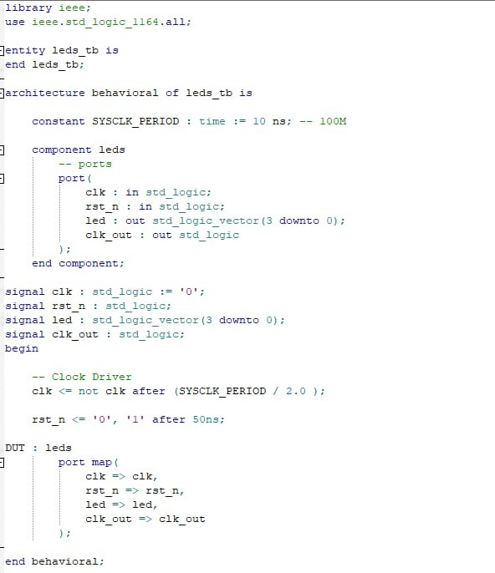
We can use the Check HDL File option to check if we have no errors in the code.
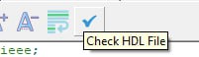
Then in the Stimulus tab, the structured testbench appears with the FW to simulate.
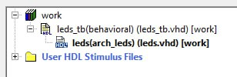
The next thing to do is to convert the testbench into the simulation file, to do this we click on Set as active stimulus.
When you click on it, the simulation symbol appears next to it, this is good because we can have different simulations in a single project.
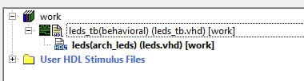
The next step is to click Simulate to open ModelSim.
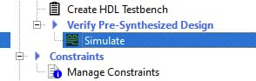
ModelSim will open automatically.
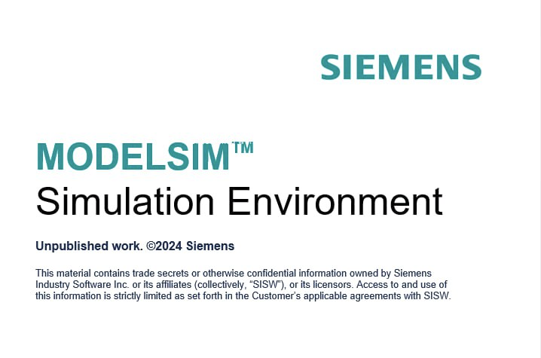
When ModelSim opens, it appears that you have done a mini-simulation of the project.
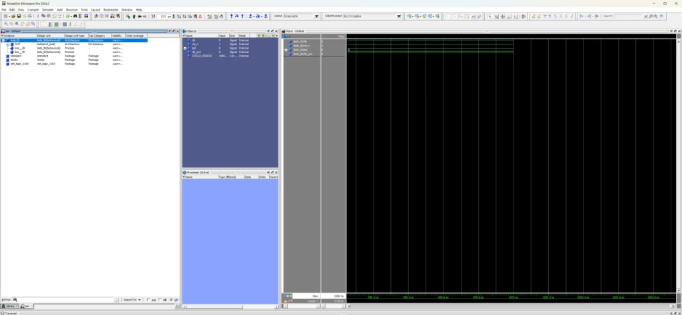
The ModelSim controls are as follows.
- Visual control: this option allows you to zoom in or put the entire simulation in a single tab (the blue magnifying glass).
- Simulation control: from left to right, the first icon is the simulation reset; the next is the simulation step; the next is the simulation with the previous time; the next is the point-to-point simulation; the next is the simulation without time restriction (the simulation will not be seen until it is stopped); the next is the simulation cancellation; and the last is the simulation stop without time restriction.
To add more ports and signals to the simulation you have two ways. Right-click the module you want to add the signals to and then Add Wave.
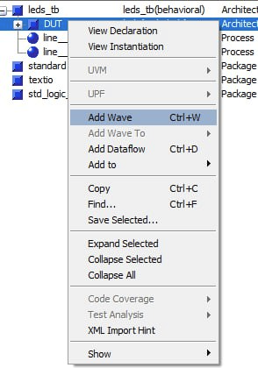
Or mark the module and click on the plus with the green symbol.
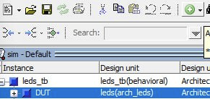
The simulation would look like this.
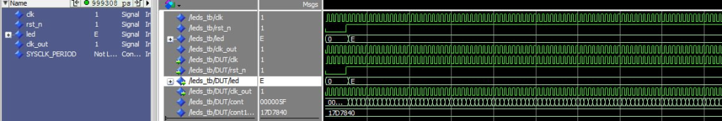
NOTE: All files for both FW and testbench are in the work library.
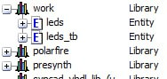
The rest of the simulations, such as post-synthesis and post-implementation, are done in the same way.

